REVIEW 3

REPORT FILE

Table used by Prem :- Loan, Payment, Debit Card, Credit Card, Customer Table

Table used by Chiranjeev:- ATM, banktobank, Branch, Insurance, Mobile Banking

Tabke used by Aadit:-Transactions, Account, Merchant, Government Service, Bank Security

PREM LOHIA TABLES

TABLE CUSTOMER

Add a new column

ALTER TABLE customer

ADD Gender CHAR(1);

Modify existing column

ALTER TABLE customer

MODIFY (DOB DATE)

Rename column

ALTER TABLE customer

RENAME COLUMN Email_id TO Email;

DROP TABLE customer;

TRUNCATE TABLE customer;

REVOKE INSERT, UPDATE, DELETE ON customer FROM user_name;

TABLE PAYMENT

Add a new column

ALTER TABLE Payment

ADD Description VARCHAR2(25);

Modify column datatype

ALTER TABLE Payment

MODIFY (Payment_amount NUMBER(12, 2));

Rename table

ALTER TABLE Payment

RENAME TO TransactionDetails;

DROP TABLE Payment;

TRUNCATE TABLE Payment;

REVOKE ALL PRIVILEGES ON Payment FROM user_name;

TABLE CreditCard:

Add a new column

ALTER TABLE CreditCard

ADD CVV NUMBER(3);

Rename column

ALTER TABLE CreditCard

RENAME COLUMN card_holder_name TO holder_name;

DROP TABLE CreditCard;

TRUNCATE TABLE CreditCard;

REVOKE SELECT ON CreditCard FROM user_name;

TABLE DebitCard:

Add a new column

ALTER TABLE DebitCard

ADD Bank VARCHAR2(100);

Modify column datatype

ALTER TABLE DebitCard

MODIFY (expiration_date DATE);

Rename table

ALTER TABLE DebitCard

RENAME TO DebitCardDetails;

DROP TABLE DebitCard;

TRUNCATE TABLE DebitCard;

REVOKE INSERT, UPDATE ON DebitCard FROM user_name;

CHIRANJEEV KUMAR TABLES

TABLE branch:

Add a new column

ALTER TABLE branch

ADD branch_manager VARCHAR2(50);

Modify existing column

ALTER TABLE branch

MODIFY IFSC_code VARCHAR2(11);

Rename column

ALTER TABLE branch

RENAME COLUMN assests TO assets;

DROP TABLE branch;

TRUNCATE TABLE branch;

RENAME branch TO branches;

REVOKE INSERT, UPDATE, DELETE ON branch FROM user_name;

TABLE Insurance:

Add a new column

ALTER TABLE Insurance

ADD coverage_amount DECIMAL(10,2);

Modify column datatype

ALTER TABLE Insurance

MODIFY (start_date DATE, end_date DATE);

Rename table

ALTER TABLE Insurance

RENAME TO InsurancePolicy;

DROP TABLE InsurancePolicy;

TRUNCATE TABLE InsurancePolicy;

REVOKE ALL PRIVILEGES ON InsurancePolicy FROM user_name;

TABLE banktobank:

Add a new column

ALTER TABLE banktobank

ADD transaction_type VARCHAR2(20);

Modify column datatype

ALTER TABLE banktobank

MODIFY (amount DECIMAL(15,2), transaction_date TIMESTAMP);

DROP TABLE BankTransactions;

TRUNCATE TABLE BankTransactions;

RENAME BankTransactions TO BankTransfers;

REVOKE SELECT ON BankTransactions FROM user_name;

TABLE ATM_CARD:

Add a new column

ALTER TABLE ATM_CARD

ADD ATM_location VARCHAR2(100);

Modify column datatype

ALTER TABLE ATM_CARD

MODIFY (AmountWithdrawal DECIMAL(16,2), TransactionID INT);

DROP TABLE ATMTransactions;

TRUNCATE TABLE ATMTransactions;

RENAME ATMTransactions TO ATMTransfers;

REVOKE INSERT, UPDATE ON ATMTransactions FROM user_name;

TABLE MobileBankingApps:

Add a new column

ALTER TABLE MobileBankingApps

ADD LastLoginDate DATE;

Modify column datatype

ALTER TABLE MobileBankingApps

MODIFY (AppName VARCHAR2(100));

DROP TABLE MobileApps;

TRUNCATE TABLE MobileApps;

RENAME MobileApps TO MobileApplications;

REVOKE ALL PRIVILEGES ON MobileApps FROM user_name;

AADIT VINAYAK TABLES

TABLE account:

Add a new column

ALTER TABLE account

Modify existing column

ALTER TABLE account

MODIFY (Saving_account VARCHAR(3), Current_account VARCHAR(3));

Rename column

ALTER TABLE account

RENAME COLUMN Balance TO AccountBalance;

DROP TABLE account;

TRUNCATE TABLE account;

RENAME account TO accounts;

REVOKE INSERT, UPDATE, DELETE ON account FROM user_name;

TABLE Transactions:

Add a new column

ALTER TABLE Transactions

ADD Description VARCHAR(255);

Modify column datatype

ALTER TABLE Transactions

MODIFY (TransactionDate TIMESTAMP);

Rename table

ALTER TABLE Transactions

RENAME TO BankTransactions;

DROP TABLE BankTransactions;

TRUNCATE TABLE BankTransactions;

RENAME BankTransactions TO Transactions;

REVOKE ALL PRIVILEGES ON Transactions FROM user_name;

TABLE merchant:

Add a new column

ALTER TABLE merchant

ADD TransactionDescription VARCHAR(255);

Modify column datatype

ALTER TABLE merchant

MODIFY (phone_no VARCHAR2(15));

DROP TABLE MerchantTransactions

TRUNCATE TABLE MerchantTransactions;

RENAME MerchantTransactions TO MerchantTrans;

REVOKE SELECT ON MerchantTrans FROM user_name;

TABLE BankSecurity:

Add a new column

ALTER TABLE BankSecurity

ADD LastPasswordChangeDate DATE;

Modify column datatype

ALTER TABLE BankSecurity

MODIFY (AccountLockStatus VARCHAR2(20));

DROP TABLE UserSecurity;

TRUNCATE TABLE UserSecurity;

RENAME UserSecurity TO UserSec;

REVOKE INSERT, UPDATE ON UserSec FROM user_name;

TABLE GovernmentServices:

Add a new column

ALTER TABLE GovernmentServices

ADD ServiceCategory VARCHAR(50);

Modify column datatype

ALTER TABLE GovernmentServices

MODIFY (ServiceName VARCHAR2(100));

DROP TABLE GovtServices;

TRUNCATE TABLE GovtServices;

RENAME GovtServices TO GovernmentServices;

REVOKE ALL PRIVILEGES ON GovernmentServices FROM user_name;

PREM LOHIA

PLSQL CURSOR TRIGGERS

PL/SQL UPDATED CODE

Q1 : Write a PL/SQL block to add 10% more interest on loan type = home loan

ANSWER:NORMAL PLSQL

SET SERVEROUTPUT ON

DECLARE

v_account_no loan1.account_no%TYPE;

v_loan_type loan1.loan_type%TYPE;

v_loan_no loan1.loan_no%TYPE;

v_amount loan1.amount%TYPE;

v_interest loan1.interest%TYPE;

BEGIN

-- Update interest for home loans

FOR loan_rec IN (SELECT * FROM loan1 WHERE loan_type = 'Home loan') LOOP

v_account_no := loan_rec.account_no;

v_loan_type := loan_rec.loan_type;

v_loan_no := loan_rec.loan_no;

v_amount := loan_rec.amount;

v_interest := loan_rec.interest;

-- Calculate 10% more interest for home loans

v_interest := v_interest + (v_interest * 0.1);

-- Update interest rate in loan1 table

UPDATE loan1

SET interest = v_interest

WHERE account_no = v_account_no;

-- Output the changes made

DBMS_OUTPUT.PUT_LINE('Interest rate for ' || v_loan_type || ' with Account No ' || v_account_no || ' updated to ' || v_interest);

END LOOP;

-- Display the updated table

FOR loan_rec IN (SELECT * FROM loan1) LOOP

DBMS_OUTPUT.PUT_LINE('Account No: ' || loan_rec.account_no || ', Loan Type: ' || loan_rec.loan_type || ', Loan No: ' || loan_rec.loan_no || ', Amount: ' || loan_rec.amount || ', Interest: ' || loan_rec.interest);

END LOOP;

-- Commit the changes

COMMIT;

EXCEPTION

WHEN OTHERS THEN

-- Handle exceptions

DBMS_OUTPUT.PUT_LINE('Error: ' || SQLERRM);

ROLLBACK;

END;

/

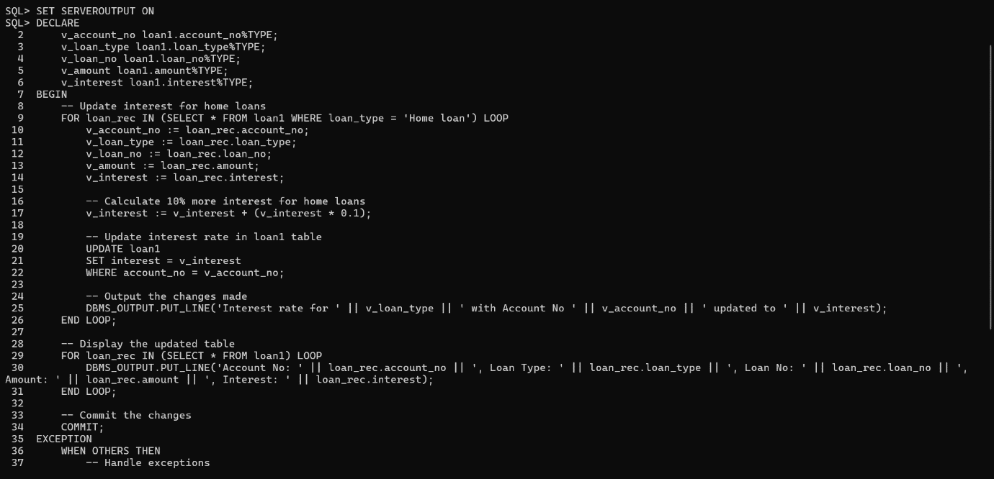

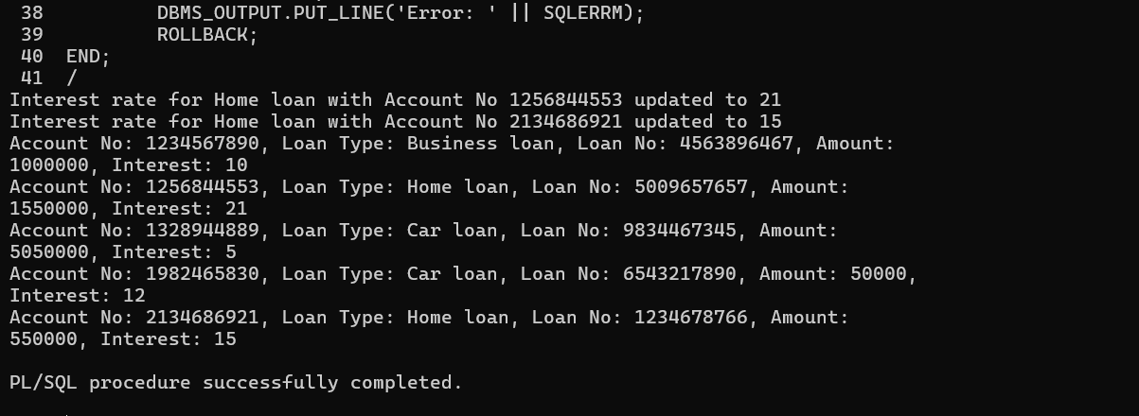

Q2 :Write a before trigger to add 10000 ruppee to customer table debit card whose amount is more than 75000

ANSWER: BEFORE INSERT trigger

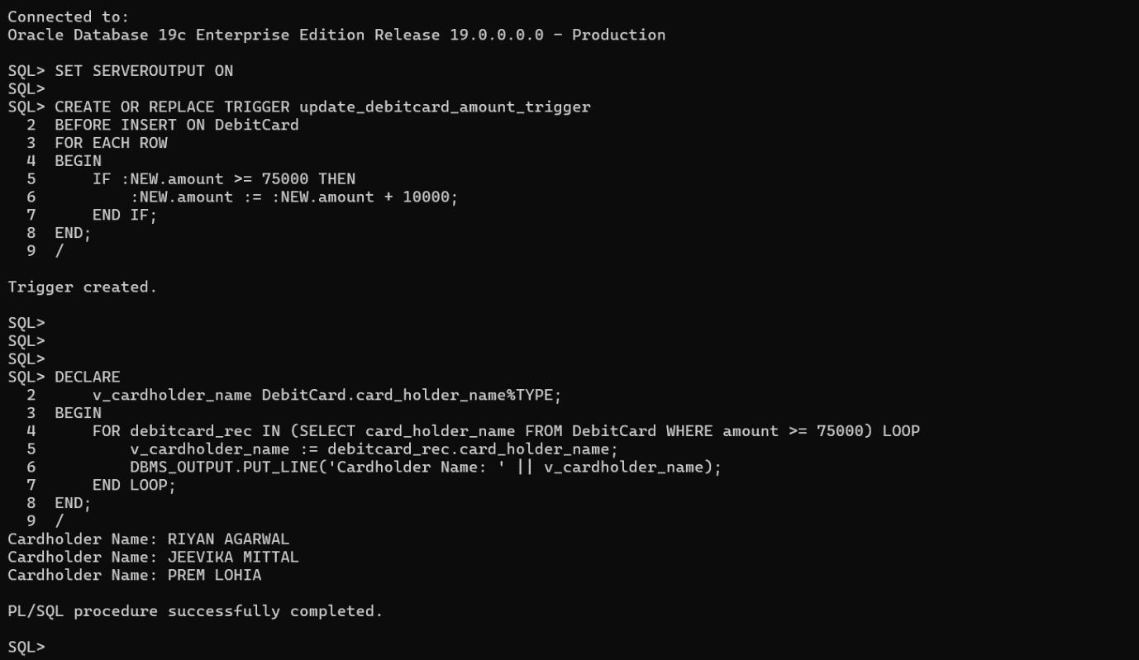

SET SERVEROUTPUT ON

CREATE OR REPLACE TRIGGER update_debitcard_amount_trigger

BEFORE INSERT ON DebitCard

FOR EACH ROW

BEGIN

IF :NEW.amount >= 75000 THEN

:NEW.amount := :NEW.amount +10000;

END IF;

END;

/

DECLARE

v_cardholder_name DebitCard.card_holder_name%TYPE;

BEGIN

FOR debitcard_rec IN (SELECT card_holder_name FROM DebitCard WHERE amount >=75000) LOOP

v_cardholder_name := debitcard_rec.card_holder_name;

DBMS_OUTPUT.PUT_LINE('Cardholder Name: ' || v_cardholder_name);

END LOOP;

END;

/

Q3:Write a plsql code of explicit cursor to display all the email_id af all customer name from table customer

ANSWER: EXPLACIT CURSOR

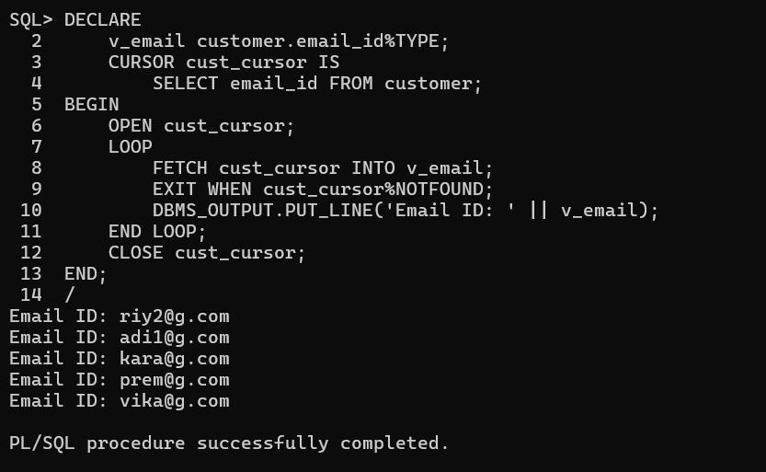

DECLARE

v_email customer.email_id%TYPE;

CURSOR cust_cursor IS

SELECT email_id FROM customer;

BEGIN

OPEN cust_cursor;

LOOP

FETCH cust_cursor INTO v_email;

EXIT WHEN cust_cursor%NOTFOUND;

DBMS_OUTPUT.PUT_LINE('Email ID: ' || v_email);

END LOOP;

CLOSE cust_cursor;

END;

/

Q4:write a plsql code of implicite cursor to diaplay the card_holder_name of those people who have expiration_date after year 2026 and also display result as an output

ANSWER: : IMPLICIT CURSOR

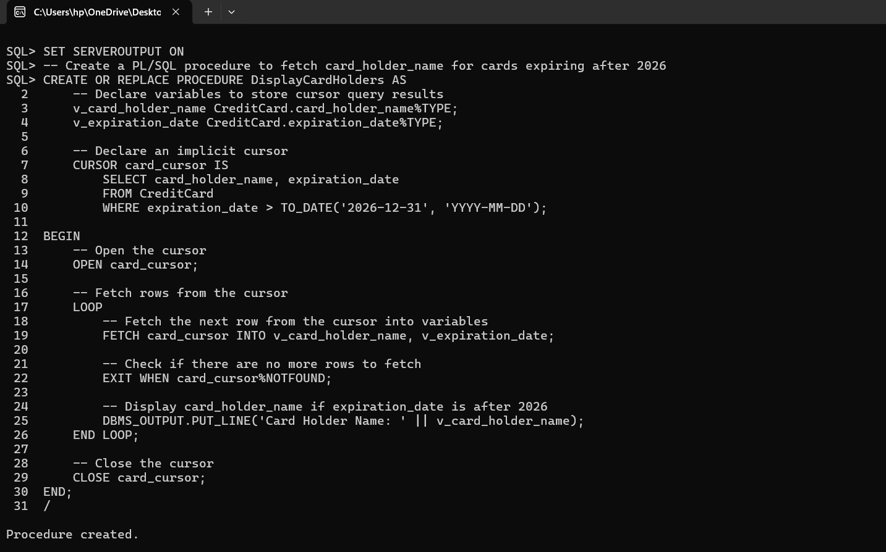

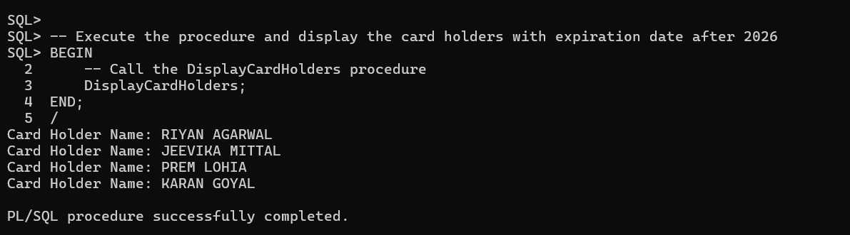

SQL> SET SERVEROUTPUT ON

-- Create a PL/SQL procedure to fetch card_holder_name for cards expiring after 2026

SQL> CREATE OR REPLACE PROCEDURE DisplayCardHolders AS

v_card_holder_name CreditCard.card_holder_name%TYPE;

v_expiration_date CreditCard.expiration_date%TYPE;

-- Declare an implicit cursor

CURSOR card_cursor IS

SELECT card_holder_name, expiration_date

FROM CreditCard

WHERE expiration_date > TO_DATE('2026-12-31', 'YYYY-MM-DD');

BEGIN

-- Open the cursor

OPEN card_cursor;

LOOP

-- Fetch the next row from the cursor into variables

FETCH card_cursor INTO v_card_holder_name, v_expiration_date;

-- Check if there are no more rows to fetch

EXIT WHEN card_cursor%NOTFOUND;

-- Display card holder name if expiration date is after 2026

DBMS_OUTPUT.PUT_LINE('Card Holder Name: ' || v_card_holder_name);

END LOOP;

-- Close the cursor

CLOSE card_cursor;

END;

/

-- Execute the procedure and display the card holders with expiration date after 2026

BEGIN

DisplayCardHolders;

END;

/

Q5: create a view and add all column from customer and add card no and amount from debit card and also show the view as output with table name view1

ANSWER: CREATING VIEW1

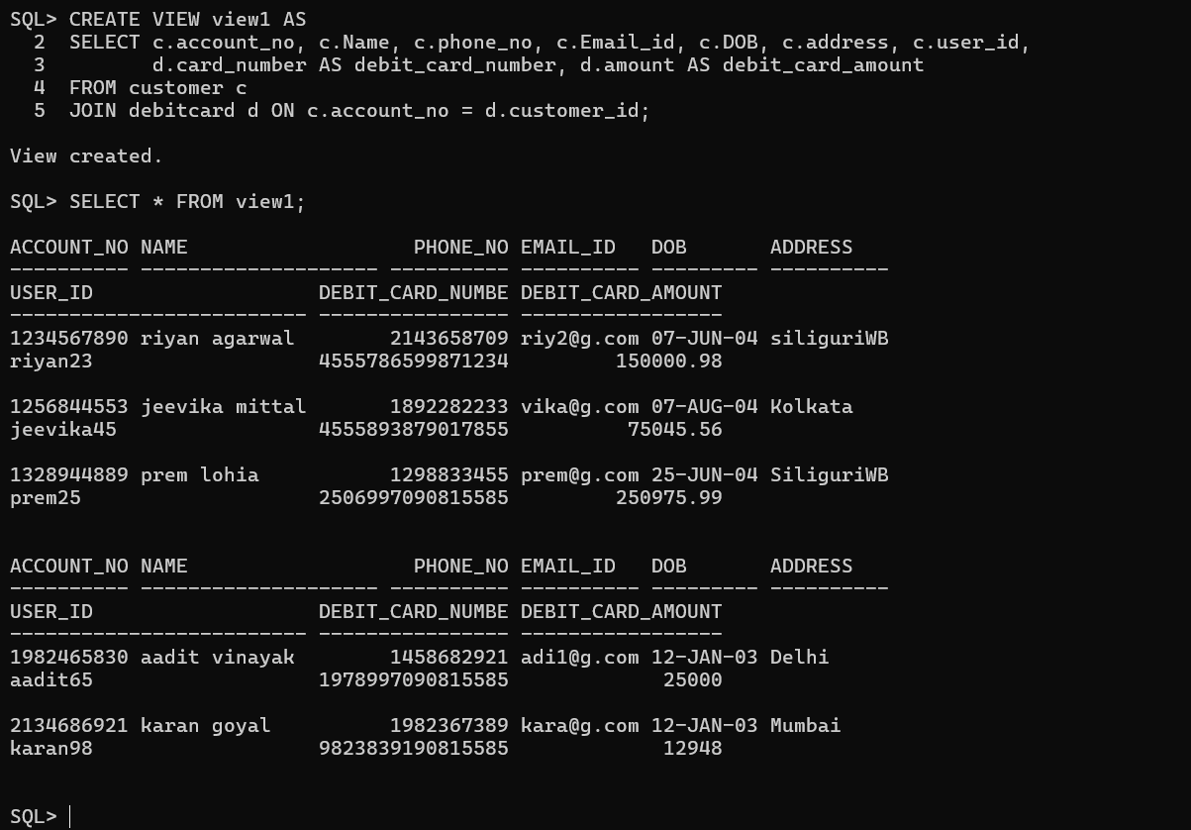

NORMAL PLSQL ,CURSOR , TRIGGER,VIEW

CHIRANJEEV KUMAR

Q1) write a NORMAL PL/SQL block to change the amount from branch name = navi branch from BanktoBank x table and decrease amount to 1000 from all columns of the table using cursor

SET SERVEROUTPUT ON;

DECLARE

CURSOR c_bank_cur IS

SELECT bank_name, branch, amount, transaction_date, account_no

FROM banktobank

WHERE branch = 'NAVI BRANCH'; -- Use 'branch' instead of 'branch_name'

v_bank_name banktobank.bank_name%TYPE;

v_branch banktobank.branch%TYPE; -- Correct variable name for branch

v_amount DECIMAL(15, 2); -- Correct data type declaration for amount

v_timestamp TIMESTAMP;

v_account_number banktobank.account_no%TYPE; -- Use correct column name

BEGIN

FOR bank_rec IN c_bank_cur LOOP

v_bank_name := bank_rec.bank_name;

v_branch := bank_rec.branch;

v_amount := bank_rec.amount - 1000;

v_timestamp := bank_rec.transaction_date;

v_account_number := bank_rec.account_n

CODE

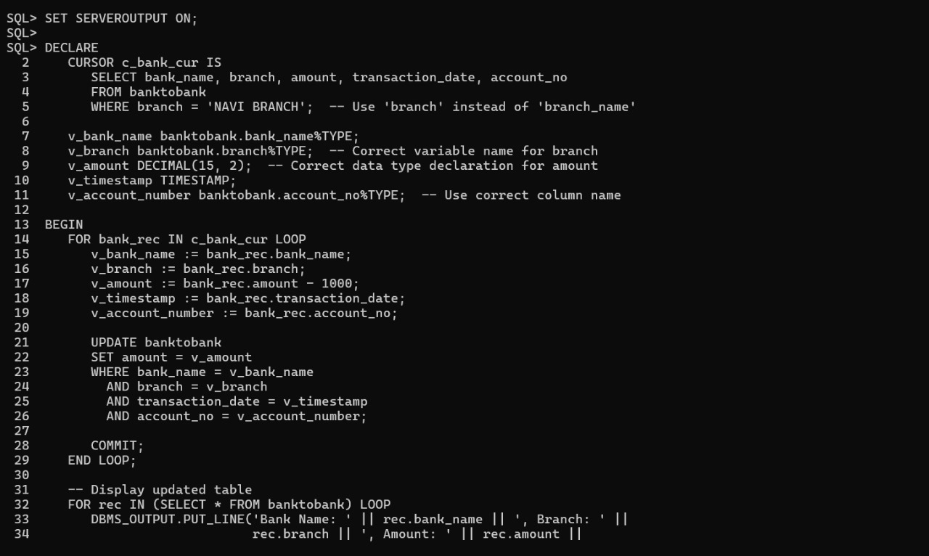

OUTPUT

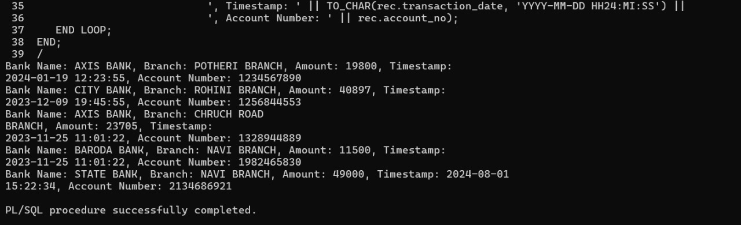

Q2) write a PL/SQL block to change the insurancex table, premium_amount who have coverage_details of Hospital bills , Accident bills will increase premium amount by 20 percent more by using trigger

BEFORE trigger

SET SERVEROUTPUT ON;

CREATE OR REPLACE TRIGGER adjust_premium_trigger

BEFORE INSERT OR UPDATE ON insurance

FOR EACH ROW

BEGIN

IF :NEW.coverage_details = 'hospital bills' OR :NEW.coverage_details = 'Accidents' THEN

:NEW.premium_amount := :NEW.premium_amount * 1.20; -- Increase premium amount

by 20%

END IF;

END;

/

DECLARE

BEGIN

-- Display updated table

FOR rec IN (SELECT * FROM insurance) LOOP

DBMS_OUTPUT.PUT_LINE('Policy Number: ' || rec.policy_number || ', Customer ID: ' ||

rec.customer_id || ', Type: ' || rec.insurance_type || ', Premium Amount: ' ||

rec.premium_amount || ', Start Date: ' || TO_CHAR(rec.start_date, 'YYYY-MM-DD') || ', End

Date: ' || TO_CHAR(rec.end_date, 'YYYY-MM-DD') || ', Coverage Details: ' ||

rec.coverage_details);

END LOOP;

END;

\

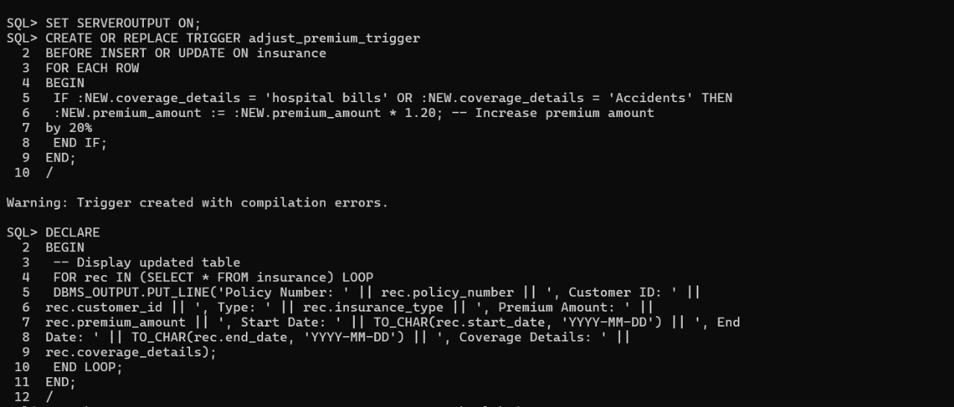

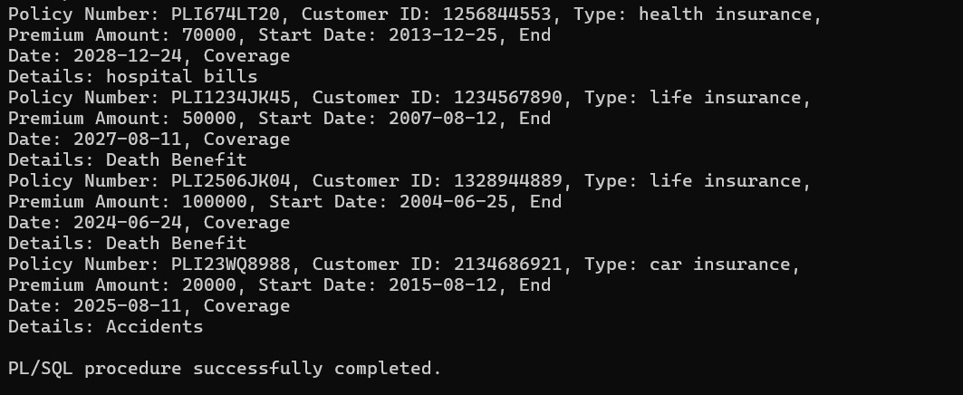

Q3) write a plsql code of implicite cursor to diaplay the account _noe of those who have transaction_date after year 2023

implicit cursor

SET SERVEROUTPUT ON;

DECLARE

v_account_no banktobank.account_no%TYPE;

BEGIN

-- Open cursor to fetch account numbers with transaction dates after 2023

FOR rec IN (SELECT account_no FROM banktobank WHERE EXTRACT(YEAR FROM transaction_date) > 2023) LOOP

v_account_no := rec.account_no;

-- Display account numbers

DBMS_OUTPUT.PUT_LINE('Account Number: ' || v_account_no);

END LOOP;

END;

/

